Reception Home Learning Support for Autumn 1 2021
Hello to all of our children and their parents and carers. Your children have already started to learn new school routines, new words and make some new friends .The following learning activities and ideas will help your child to become increasingly independent as they journey through their reception year.
Do a little bit every day if you can reading | Creative/ Personal social and emotional, talking | Physical | Self Help
Each week your child will come home with a book on Thursday which needs to be returned on Tuesday. The first books are picture books. Please help your child to talk about these books, tell a story and make comments about the things they see. They can share the book more than once as this builds their skills and confidence. Share other favourite stories at bedtime. Children who hear lots of stories will learn lots of words to use when they talk and when they learn to write.  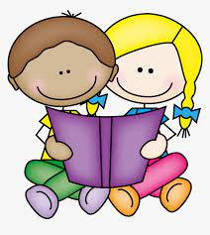 | Make a poster with your child about themselves –they could use stickers and photos as well as drawings. You could include family, things you really like, your favourite stories, songs and music and the things you like to eat. Let your child describe their poster and tell you all about themselves. This will help them to share it at school. Please bring this to school on Friday 0ctober the  15th and we can share these the following week. | At school we learn to cross the midline of our body. This helps us to use our body with our brain. If you google or ‘you tube’ crossing the midline’ you will find lots of songs and dances to support this. We call this time at school wiggle time.  https://www.youtube.com/watch?v=RRlY1vWLS0o  https://www.youtube.com/watch?v=YFe0I8kkFOg&list=PLoI292-QMc23HJk3jDg6SbRDFKHR4tgns  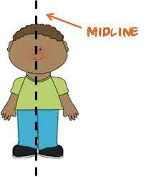 | Part of Reception learning is to begin to learn to look after ourselves and manage our own needs. This gives your child a sense of self-esteem.  With this in mind can you help your child to practise-  Undoing cardigan buttons and doing them up again.  Turning their coats and cardigans the correct way round from inside out.  Doing a coat zip up  Wiping their bottom  Thank you so much for your support,  we will help your child to learn these skills too .  