Design it!  Can you design a home for a pet of your choice?  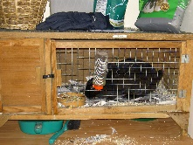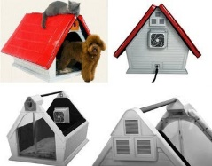  Draw a labelled diagram of what it will look like and what it will need to be a good home for the pet. | Draw it!  Using your sketching skills try sketching an object. It could be a favourite animal or toy or even a plant or a person. Use your pencil carefully to add details. Try using lines of different thicknesses and use dots and shading to complete your sketch.  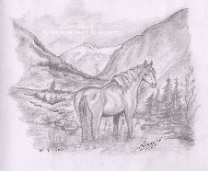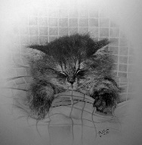 | Calculate it!  Can you recall number facts to 10? How about to 20? What about to 100?  So…  7 + 3 = 10 10 – 7 = 3  3 + 7 = 10 10 – 3 = 7  17 + 3 =20 20 - 3 =17  3 + 17 =20 20 - 7 =3  70 + 30 = 100
Write it!  Write a fact page for an animal of your choice. Think about what it looks like, what it eats and where it lives. Can you add some fun facts?  Try using headings and sub-headings to organise your information. | Year 2 Autumn 1  Home Learning  Each week choose one of the activities to complete at home. Return your home learning books by the following Wednesday to share with your teacher before they are given out again. We look forward to seeing your fantastic home learning! | Read it! (Every week)  Our reading focus for this half term is …  Sequence the key events in the story  Example questions:  What happened after…?  What was the first thing that happened?  Can you summarise what happened at the beginning, middle and end of the story?  In what order do these chapter headings come in the story?  What does the main character do in the middle of the story?
Vocabulary – discuss with your child  mammal herbivore  numeral digit  waterproof material  partition place value  fiction factual | Investigate It!  Animals need a waterproof shelter. Can you investigate different materials to find out which would be the most suitable for a shelter? | Play it!  Play some maths games together either on the tablet or computer or board games such as snakes and ladders.  Explore the maths games on Purple Mash or topmarks.co.uk.

