Design it!  Design a new vehicle. How many wheels will it have? Draw a picture of your vehicle and label all the parts.  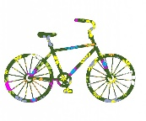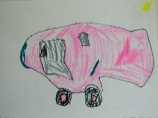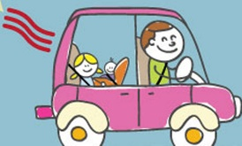  If you want to make a vehicle take a picture of your finished model and stick it in your book. | Draw it!  Draw a picture of your favourite thing. Can you use your sketching skills to add details, using thick and thin lines and small dots? Use lots of colours and patterns to make your picture really beautiful. Take your time and be proud of your art skills.  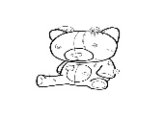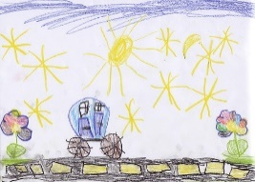 | Count It!  What can you count?  Try steps up the stairs  Wheels on a car  Tins in the cupboard  Beans on your plate.  You can count anything, have a go and write a list of the things you counted in your home learning book.
Write it!  Write about your family. Who do you live with? Who do you visit with your family?  How many brothers and sisters do you have and do you have any pets?  What do you like to do together?  Include a photograph or draw a picture and label who is who. | Year 1 Autumn 1  Home Learning  Each week choose one of the activities to complete at home. Return your home learning books by the following Wednesday to share with your teacher before they are given out again. We look forward to seeing your fantastic home learning! | Read it! (Every week)  Our reading focus for this half term is …  Sequence- the key events in the story  Example questions:  What happened after…?  What was the first thing that happened?  Can you summarise what happened at the beginning, middle and end of the story?  Spell it!  Every week practise your spellings
Collect It!  Collect information about how many red, blue or white cars you can spot in five minutes. Draw a picture of the coloured car you see the most of and write how many you saw.  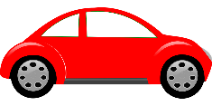 | Investigate It!  Go for a walk in the park and investigate the changes that are starting to happen. Are the trees changing? What about the colours. Can you find any natural objects to collect? What are the special names of the things you have found? | Number it!  Write rainbow coloured digits from 0-10 in a fancy pattern. Can you count further?
Sense it!
Using the senses sheet in your book, draw or write what you see, hear, smell, touch and taste on your way to school.

